Docker Tutorials for Java Developers

Consider a scenario - You have just joined a new organization as a developer. You will now have to setup the project with the assistance of a fellow developer. He suggests you follow certain steps for setting up the required environment and then start the project deployable like a WAR. You do the same, but keep getting some or other issues regarding environment configuration. May be even your fellow developer has forgot some configuration property he might have set. Well you are stuck in such a situation. This is known as Dependency Hell. Other similar scenario of this dependency hell are - The application is running on my dev machine but not in production. Dont know what issue is. There is also other scenarios like Matrix of Hell. But this is mostly related to DEVOPS people. Docker to the rescue.
Docker is a tool designed to make it easier to create, deploy, and run applications by using containers.

Containers allow a developer to package up an application with all of the parts it needs, such as libraries and other dependencies, and ship it all out as one package. Create self-contained development environments inside Docker containers. So we share an environment already configured.
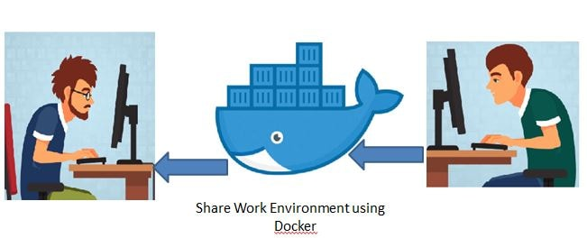

This is done using a docker image.
An image is a lightweight, stand-alone, executable package that includes everything needed to run a piece of software, including the code, a runtime, libraries, environment variables, and config files.
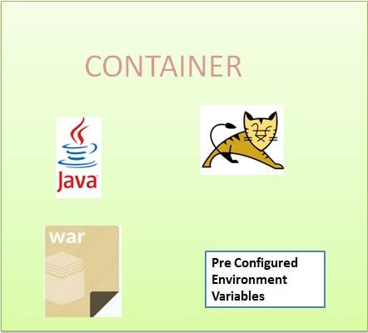

So an existing fellow developer will create an image of his environment and share it with the new developer. The new developer will just have to run the image as a docker container.

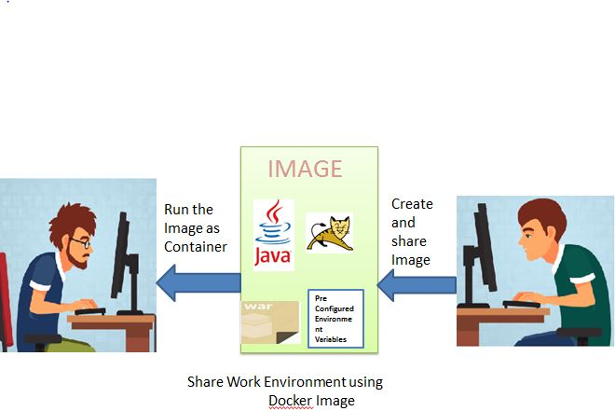

A container is a runtime instance of an image what the image becomes in memory when actually executed. It runs completely isolated from the host environment by default, only accessing host files and ports if configured to do so. So the following scenarios we can consider the use of docker for Java Developers-
Sharing development workspace, with preconfigured development environment.
Continuous integration is one of the most popular use cases for Docker. Teams looking build and deploy their applications quickly use Docker, combined with ecosystem tools like Jenkins, to drive apps from dev, testing staging and into production without having to change any code.
Running UAT's using Docker
In this series we will be starting with basic understanding of docker and then move to more complex topics like docker swarms, running UAT's etc.
Also Docker is a very vast topic, but we will be covering as to what is needed for Java Developers. Also docker involves lots of commands. We have created a single page to note down all the docker commands we will using.
Also for all docker example have Centos image and Oracle VM for running the examples.

Deploying Spring Boot Microservice to Docker

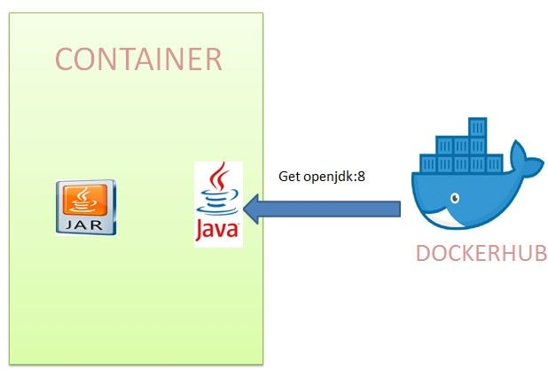
step 1: create emp-producer project, create hello controller

Give final name inside build :<finalName>emp-producer</finalName>

public class Employee {
private int id;
private String name;
private double salary;}

@RestController
public class EmployeeController {

@GetMapping(path = "employee")
public Employee getEmployee() {
return new Employee(121, "raj", 4000);
}
}

test and run it

step 2: Create Dockerfile

FROM openjdk:11
EXPOSE 8080
ADD target/emp-producer.jar emp-producer.jar
ENTRYPOINT ["java","-jar","emp-producer.jar"]

step 3: create image using command
docker build -t emp-producer .

docker image ls

step 4: run image
docker run -p 8080:8080 emp-producer

step 5: push image to docker hub

first login : docker login

then run command :
docker tag hello-docker rajiv2018/emp-producer
docker push rajiv2018/emp-producer

step 6: pull image from the docker hub

docker push rajiv2018/emp-producer

step 7: other person now can pull the image

remove the images
docker images
docker image rmi <imgid> -f

now pull the image and run it
docker run -p 8080:8080 rajiv2018/emp-producer

Docker networking

we saw how to deploy a single Spring Boot Microservice to Docker Container. But suppose the requirement is such that we may need to deploy multiple microservices to Docker Container. For example we have the following microservices that we have defined in previous tutorial.

As the name suggests employee-producer will be exposing REST APIs which will be consumed by the employee-consumer.
The way Docker has been designed such that a Docker Container should have only a single service running. Again we can have multiple services running in docker using some workarounds but this will not be a good design. So we will be deploying the two microservices employee-producer and employee-consumer to two different containers and then have them interact with each other.

In order to achieve this will have to make use of the docker networking commands.

Docker consumer code:
________________
public class Employee {
private int id;
private String name;
private double salary;
}

@RestController
public class EmployeeConsumerController {

@Autowired
private RestTemplate restTemplate;

@GetMapping(path = "employee-consumer")
public String getEmployee() {
Employee employee=restTemplate.getForObject("http://producer:8080/employee", Employee.class);
return employee.toString();
}
}

@SpringBootApplication
public class EmpProducerApplication {

public static void main(String[] args) {
SpringApplication.run(EmpProducerApplication.class, args);
}

@Bean
public RestTemplate getRestTemplate() {
return new RestTemplate();
}
}

server.port=8081

FROM openjdk:11
EXPOSE 8081
ADD target/emp-consumer.jar emp-consumer.jar
ENTRYPOINT ["java","-jar","emp-consumer.jar"]

docker container run --name consumer -p 8081:8081 -d emp-consumer
docker container logs <id>

java.net.UnknownHostException: producer

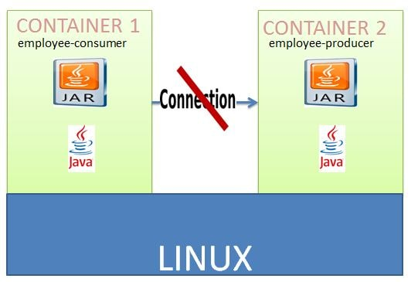

Inter Docker Container Communication Using Docker Networking

We will be using Docker Networking to allow multiple containers to interact with each other.

We will need to create our own network and add both the employee-producer and employee-consumer services to it. We will stop and remove the existing docker containers named consumer and producer.

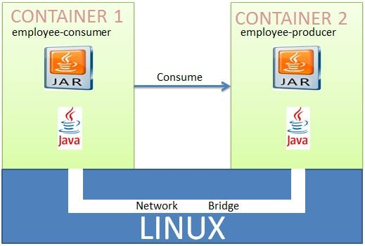

Deploying Multiple Spring Boot Microservices using Docker Compose

Previously we had to do the following steps manually-

Create custom docker network named consumer-producer network
Start Container named producer using image emp-producer and the custom network consumer-producer
Start Container named consumer using image emp-consumer and the custom network consumer-producer

The above steps can be automated using docker compose.

Compose is a tool for defining and running multi-container Docker applications. With Compose, you use a YAML file to configure your application's services. Then, with a single command, you create and start all the services from your configuration.
Using docker-compose we will be creating the custom network named consumer-producer and then starting the containers employee-producer and employee consumer.

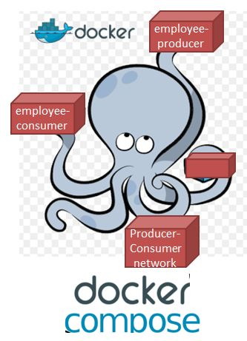

step 1: check docker-compose is installed or not?

docker-compose --version

if not found:
curl -L https://github.com/docker/compose/releases/download/1.3.1/docker-compose-`uname -s`-`uname -m` > /usr/local/bin/docker-compose

step 2: create an docker-compose.yml inside consumer project
____________________
version: "3"
services:
consumer:
image: emp-consumer
ports:
- "8081:8081"
networks:
- consumer-producer
depends_on:
- producer

producer:
image: emp-producer
ports:
- "8080:8080"
networks:
- consumer-producer

networks:
consumer-producer:

step 3: run "docker-compose up" and check

